Experiment No. 7

Aim : Designing the GUI using Swing components and IDE

1. Design a standard calculator using Swing components that supports basic operations
(Addition, Subtraction, Multiplication, and Division). Implement this with Intellij IDEA
Implementation Guidelines:
○ Use JTextField to display input/output.
○ Use JButton for digits (0-9) and operations ( +, -, *, /, =, %, square, square-root,
cube, C, etc. ).
○ Implement event handling for button clicks.
○ Display results in the text field

import javax.swing.*;
import java.awt.*;
import java.awt.event.ActionEvent;
import java.awt.event.ActionListener;
public class Calculator extends JFrame implements ActionListener {
private JTextField display;
private String operator;
private double firstOperand;
public Calculator() {
setTitle("Calculator");
setDefaultCloseOperation(JFrame.EXIT_ON_CLOSE);
setLayout(new BorderLayout());
display = new JTextField();
display.setEditable(false);
add(display, BorderLayout.NORTH);
JPanel buttonPanel = new JPanel(new GridLayout(5, 4));
String[] buttonLabels = {
"7", "8", "9", "/",
"4", "5", "6", "*",
"1", "2", "3", "-",
"0", ".", "=", "+",
"C", "sqrt", "sq", "cube"
};
for (String label : buttonLabels) {
JButton button = new JButton(label);
button.addActionListener(this);
buttonPanel.add(button);
}
add(buttonPanel, BorderLayout.CENTER);
pack();
setLocationRelativeTo(null);
}
@Override
public void actionPerformed(ActionEvent e) {
String command = e.getActionCommand();
if (Character.isDigit(command.charAt(0)) || command.equals(".")) {
display.setText(display.getText() + command);
} else if (command.equals("C")) {
display.setText("");
operator = null;
firstOperand = 0;
} else if (command.equals("=")) {
if (operator != null) {
double secondOperand = Double.parseDouble(display.getText());
double result = 0;
switch (operator) {
case "+":
result = firstOperand + secondOperand;
break;
case "-":
result = firstOperand - secondOperand;
break;
case "*":
result = firstOperand * secondOperand;
break;
case "/":
result = firstOperand / secondOperand;
break;
}
display.setText(String.valueOf(result));
operator = null;
}
} else if (command.equals("sqrt")) {
double operand = Double.parseDouble(display.getText());
display.setText(String.valueOf(Math.sqrt(operand)));
} else if (command.equals("sq")) {
double operand = Double.parseDouble(display.getText());
display.setText(String.valueOf(operand * operand));
} else if (command.equals("cube")) {
double operand = Double.parseDouble(display.getText());
display.setText(String.valueOf(operand * operand * operand));
} else {
operator = command;
firstOperand = Double.parseDouble(display.getText());
display.setText("");
}
}
public static void main(String[] args) {
SwingUtilities.invokeLater(() -> {
new Calculator().setVisible(true);
});
}
}

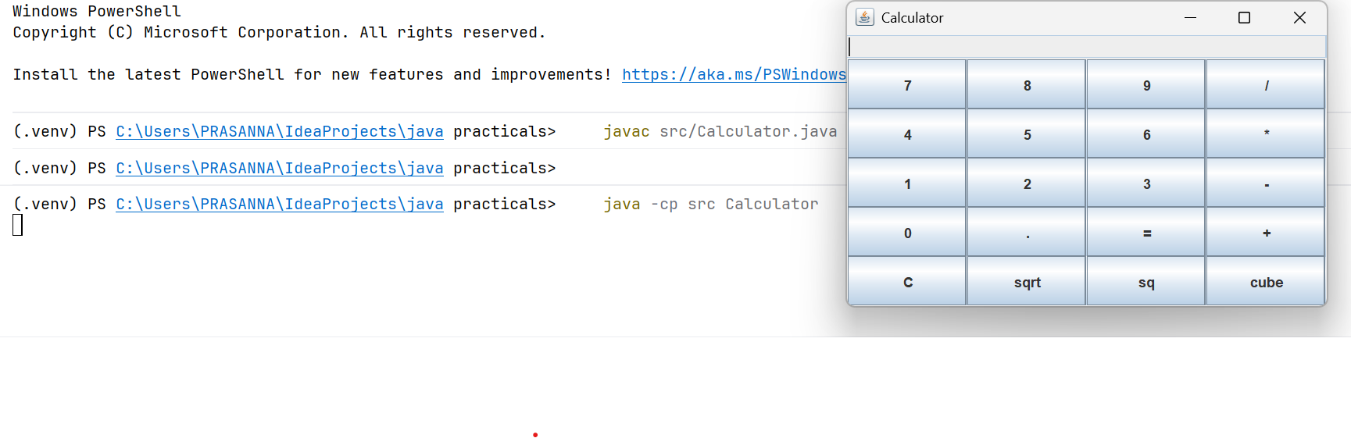

2. Implement the following problem statement using Intellij IDEA.

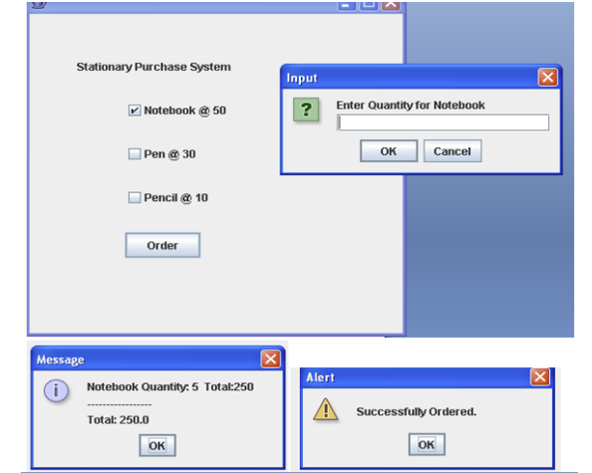

import javax.swing.*;
import java.awt.*;
import java.awt.event.*;
public class StationaryPurchaseSystem extends JFrame implements ActionListener {
JCheckBox notebook, pen, pencil;
JButton orderBtn;
int total = 0;
public StationaryPurchaseSystem() {
setTitle("Stationary Purchase System");
setSize(350, 300);
setLayout(null);
setDefaultCloseOperation(JFrame.EXIT_ON_CLOSE);
JLabel title = new JLabel("Stationary Purchase System");
title.setBounds(70, 20, 200, 20);
add(title);
notebook = new JCheckBox("Notebook @ 50");
notebook.setBounds(50, 60, 150, 20);
pen = new JCheckBox("Pen @ 30");
pen.setBounds(50, 90, 150, 20);
pencil = new JCheckBox("Pencil @ 10");
pencil.setBounds(50, 120, 150, 20);
add(notebook);
add(pen);
add(pencil);
orderBtn = new JButton("Order");
orderBtn.setBounds(100, 170, 100, 30);
orderBtn.addActionListener(this);
add(orderBtn);
setVisible(true);
}
@Override
public void actionPerformed(ActionEvent e) {
total = 0;
String message = "";
if (notebook.isSelected()) {
String qtyStr = JOptionPane.showInputDialog("Enter Quantity for Notebook:");
if (qtyStr != null && !qtyStr.isEmpty()) {
int qty = Integer.parseInt(qtyStr);
int cost = qty * 50;
total += cost;
message += "Notebook Quantity: " + qty + " Total: " + cost + "\n";
}
}
if (pen.isSelected()) {
String qtyStr = JOptionPane.showInputDialog("Enter Quantity for Pen:");
if (qtyStr != null && !qtyStr.isEmpty()) {
int qty = Integer.parseInt(qtyStr);
int cost = qty * 30;
total += cost;
message += "Pen Quantity: " + qty + " Total: " + cost + "\n";
}
}
if (pencil.isSelected()) {
String qtyStr = JOptionPane.showInputDialog("Enter Quantity for Pencil:");
if (qtyStr != null && !qtyStr.isEmpty()) {
int qty = Integer.parseInt(qtyStr);
int cost = qty * 10;
total += cost;
message += "Pencil Quantity: " + qty + " Total: " + cost + "\n";
}
}
message += "\nTotal: " + total;
JOptionPane.showMessageDialog(this, message, "Message", JOptionPane.INFORMATION_MESSAGE);
JOptionPane.showMessageDialog(this, "Successfully Ordered.", "Alert", JOptionPane.WARNING_MESSAGE);
}
public static void main(String[] args) {
new StationaryPurchaseSystem();
}
}
